# **Experiment 1**

# 1. **Create an application to implement following method using Servlet.**

- doPost method and print message "Welcome to J2EE tutorial".

- doGet method and print message "Welcome to Servlet tutorial".

Firstly we have create **Dynamic Web Project,** Under the **“Dynamic Web Project”** create a two file one is **“html”** and second is **“servlet”** under the servlet file we have passed **“doPost method“** print "Welcome to J2EE tutorial",and under the **“doGet method”** print "Welcome to Servlet tutorial".

**HTML Form (index.html)**

<!**DOCTYPE** html>

<**html**>

<**head**>

<**title**>Experiment Servlet</**title**>

<**style**>

/* Styling the body to make it centered and visually appealing */

body {

font-family: *Arial, sans-serif*; /* Set a clean, readable font */

background-color: *#f4f4f9*; /* Light gray background for contrast */

margin: *0*; /* Remove default margins */

display: *flex*; /* Use flexbox for centering content */

justify-content: *center*; /* Center content horizontally */

align-items: *center*; /* Center content vertically */

height: *100vh*; /* Set full height of the viewport */

}

/* Styling for the container box */

.form-container {

background: *white*; /* White background for the container */

padding: *20px 30px*; /* Add padding inside the container */

border-radius: *10px*; /* Rounded corners for the container */

box-shadow: *0 4px 8px rgba(0, 0, 0, 0.1)*; /* Subtle shadow for depth */

text-align: *center*; /* Center the text inside the container */

width: *300px*; /* Fixed width for the container */

}

/* Styling for the heading inside the container */

.form-container h2 {

color: *#555*; /* Dark gray text color for the heading */

margin-bottom: *20px*; /* Add space below the heading */

}

/* Styling for the forms inside the container */

.form-container form {

margin: *10px 0*; /* Add space between the forms */

}

/* Styling for the buttons */

.form-container button {

background-color: *#4CAF50*; /* Green background color */

color: *white*; /* White text color */

border: *none*; /* Remove border */

padding: *10px 20px*; /* Add padding for better appearance */

font-size: *16px*; /* Set font size */

cursor: *pointer*; /* Show pointer cursor on hover */

border-radius: *5px*; /* Rounded corners for the buttons */

width: *100%*; /* Make buttons stretch to the container's width */

transition: *background-color 0.3s ease, transform 0.3s ease*; /* Add smooth transition effects */

}

/* Hover effect for the buttons */

.form-container button:hover {

background-color: *#45a049*; /* Slightly darker green on hover */

transform: *scale(1.05)*; /* Slightly enlarge the button */

}

/* Active effect for the buttons */

.form-container button:active {

background-color: *#3e8e41*; /* Dark green on click */

}

</**style**>

</**head**>

<**body**>

<!-- Container to hold the form and buttons -->

<**div** class=*"form-container"*>

<!-- Heading inside the container -->

<**h2**>Click the buttons to make a request:</**h2**>

<!-- Form to send a POST request -->

<**form** action=*"Experiment"* method=*"post"*>

<**button** type=*"submit"*>Send POST Request</**button**>

</**form**>

<!-- Form to send a GET request -->

<**form** action=*"Experiment"* method=*"get"*>

<**button** type=*"submit"*>Send GET Request</**button**>

</**form**>

</**div**>

</**body**>

</**html**>

**Servlet Code (Experiment.java)**

import jakarta.servlet.ServletException;

import jakarta.servlet.annotation.WebServlet;

import jakarta.servlet.http.HttpServlet;

import jakarta.servlet.http.HttpServletRequest;

import jakarta.servlet.http.HttpServletResponse;

import java.io.IOException;

*@WebServlet*("/Experiment")

public class Experiment extends HttpServlet {

private static final long ***serialVersionUID*** = 1L;

public Experiment() {

super();

}

// Handles GET requests

protected void doGet(HttpServletRequest request, HttpServletResponse response) throws ServletException, IOException {

// Setting the content type of the response to HTML

response.setContentType("text/html");

// Sending an HTML response to the client with a styled message

response.getWriter().println("<html><head><style>" + getCSS() + "</style></head><body>");

response.getWriter().println("<div class='form-container'>Welcome to Servlet tutorial</div>");

response.getWriter().println("</body></html>");

}

// Handles POST requests

protected void doPost(HttpServletRequest request, HttpServletResponse response) throws ServletException, IOException {

// Setting the content type of the response to HTML

response.setContentType("text/html");

// Sending an HTML response to the client with a styled message

response.getWriter().println("<html><head><style>" + getCSS() + "</style></head><body>");

response.getWriter().println("<div class='form-container'>Welcome to J2EE tutorial</div>");

response.getWriter().println("</body></html>");

}

// Method to provide inline CSS for styling the response

private String getCSS() {

return """

body {

font-family: Arial, sans-serif;

background-color: #f4f4f9;

margin: 0;

display: flex;

justify-content: center;

align-items: center;

height: 100vh;

}

.form-container {

background: white;

color: #4CAF50;

padding: 20px 30px;

border-radius: 10px;

box-shadow: 0 4px 8px rgba(0, 0, 0, 0.1);

text-align: center;

font-size: 24px;

}

""";

}

}

**OutPut:**

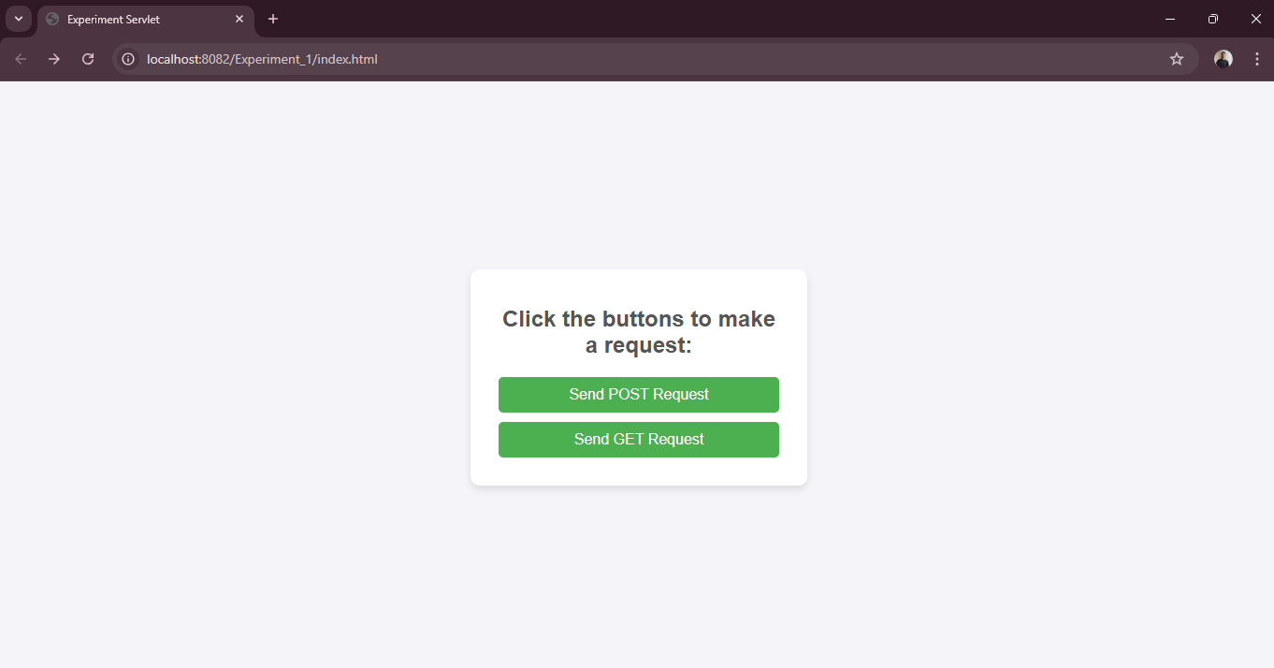

**When i tap Send POST Request it will show this Output:**

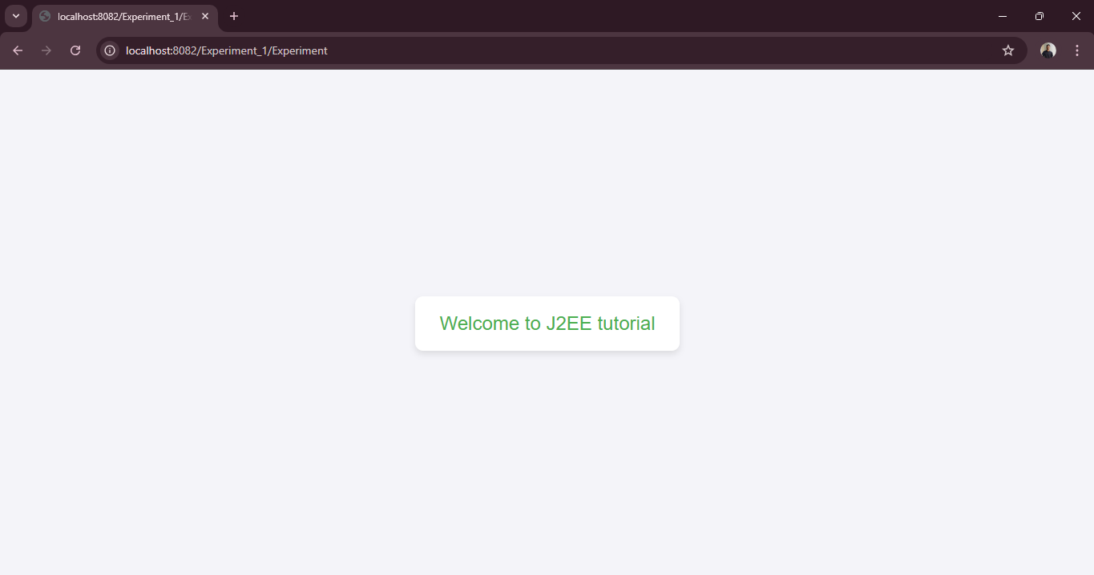

**When i tap Send GET Request it will show this Output:**

